SQUEEGEE SUPPORT NEW STYLE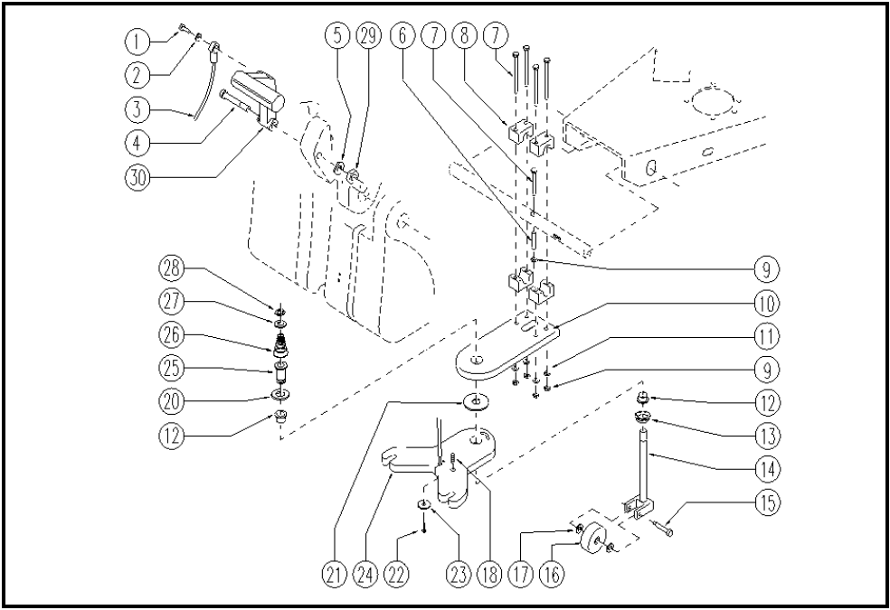

 | ITEM | SKU | DESCRIPTION | QTY | FROM
 | 1 | E88004 | Screw, Machine M4 x 12 | 1 | 10/2002
 | 2 | E89118 | Washer | 1 | 10/2002
 | 3 | E86958 | Squeegee cable | 1 | 10/2002
 | 4 | E89217 | Squeegee handle bolt | 1 | 10/2002
 | 5 | E88091 | Washer Watchman 24 | 1 | 10/2002
 | 6 | LAFN31096 | WHEEL SPACER | 1 | 10/2002
 | 7 | E86784 | Screw WS20 | 5 | 10/2002
 | 8 | E86783 | Collar WS20 | 4 | 10/2002
 | 9 | VTDD00157 | NUT M. 6 DIN 985 ZN | 5
 | 10 | E89197 | Support | 1 | 10/2002
 | 11 | E86707 | Cham Washer D10 | 4 | 10/2002
 | 12 | E89403 | Bushing | 2 | 10/2002
 | 13 | E87836 | Nut WS 24 | 1
 | 14 | E87872 | Support for WS20/24 | 1 | 10/2002
 | 15 | E87850 | Screw / Axle Squeegee Support | 1 | 04/2003
 | 16 | E87845 | Red Wheel for Watchman | 1 | 10/2002
 | 17 | E86878 | Washer | 2 | 10/2002
 | 18 | VTVT01200 | SCREW M8 X 16 INOX | 1 | 04/2004
 | 20 | E87942 | Washer, Wheel Support | 1 | 03/2004
 | 21 | E89404 | Washer | 1 | 05/2004
 | 22 | E86578 | screw WS20/24 | 1 | 10/2002
 | 23 | E86577 | washer WS20/24 | 1 | 10/2002
 | 24 | LAFN05544 | PLATE SQUEEGEE | 1 | 10/2002
 | 25 | E89405 | Pin | 1 | 10/2002
 | 26 | E89406 | Spring | 1 | 10/2002
 | 27 | E87873 | Washer for WS20 | 1 | 10/2002
 | 28 | E89408 | Stop Ring | 1 | 10/2002
 | 29 | E86462 | AS20 Nut | 1 | 10/2002
 | 30 | E89108 | Lever, Plastic Squeegee Lift | 1 | 10/2002

